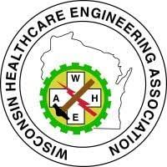 Code Committee Update February 2026

New Topic(s): None

On Going Topics – updates in Bold:

- DSPS / Wisconsin Commercial Building Code ICC Updates:
Wisconsin has adopted the 2021 ICC codes, and they went into effect on September 1, 2025.

- DHS Update –
  - Reminder: Genset Replacement projects do require an OPRI plan review
  - Checklists: DHS guidance inspection non-required checklists to assist current or future Wisconsin healthcare facility construction.

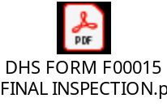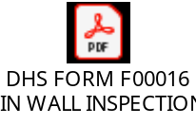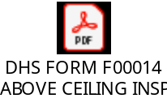

- DHS/DQA Portal: The snip below is from the 1.13.26 DHS Healthcare in the Built Environment meeting. Thanks to DHS for providing the info.

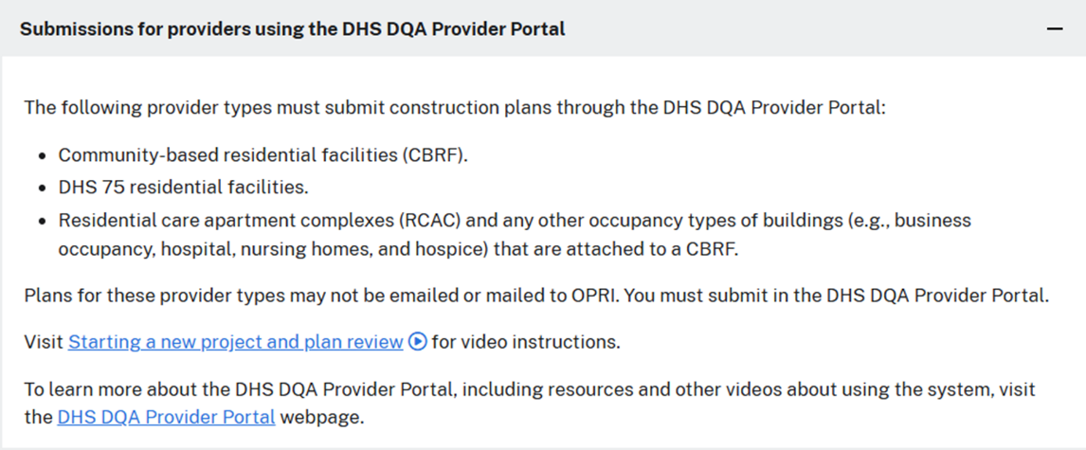

- FGI
  - 2022 editions: TJC and DNV adopting the "current edition" which is the 2022 edition.
  - 2026 editions: In progress

- CMS Update: No updates

- NFPA
  - NFPA 101 and 99 – 2024 Editions: No updates on AHJ (CMS, DHS or AO) adoption.

- Code to Care in 2025. Look for more on this in 2026

- Others News – none

